Navigate through Pages
Use this control to move through a list or library that has multiple pages. There are also arrows at the bottom of the list or library for this purpose.
- Navigate to the list or library.
- On the ribbon, click the LIST or LIBRARY tab. If there is more than one page, the Previous and Next arrows in the Manage Views group become active.
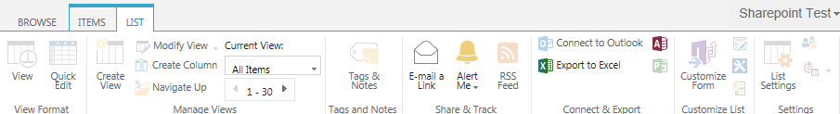
- Click the arrows to move back and forth through the pages.
